SWE316
HW1
Date of Submission : 30/9/2023
Name : Hussain Asim Al Sayedali
Id : 202038340

Task | Grade | Your Grade | Comments
Task # 1: Class Diagram | 30
Task # 2: Application | 50
Check list and penalties
No Cover page with grade table -10 ¨
File name (report) -5 ¨
Not in PDF format -10 ¨
Total | 80

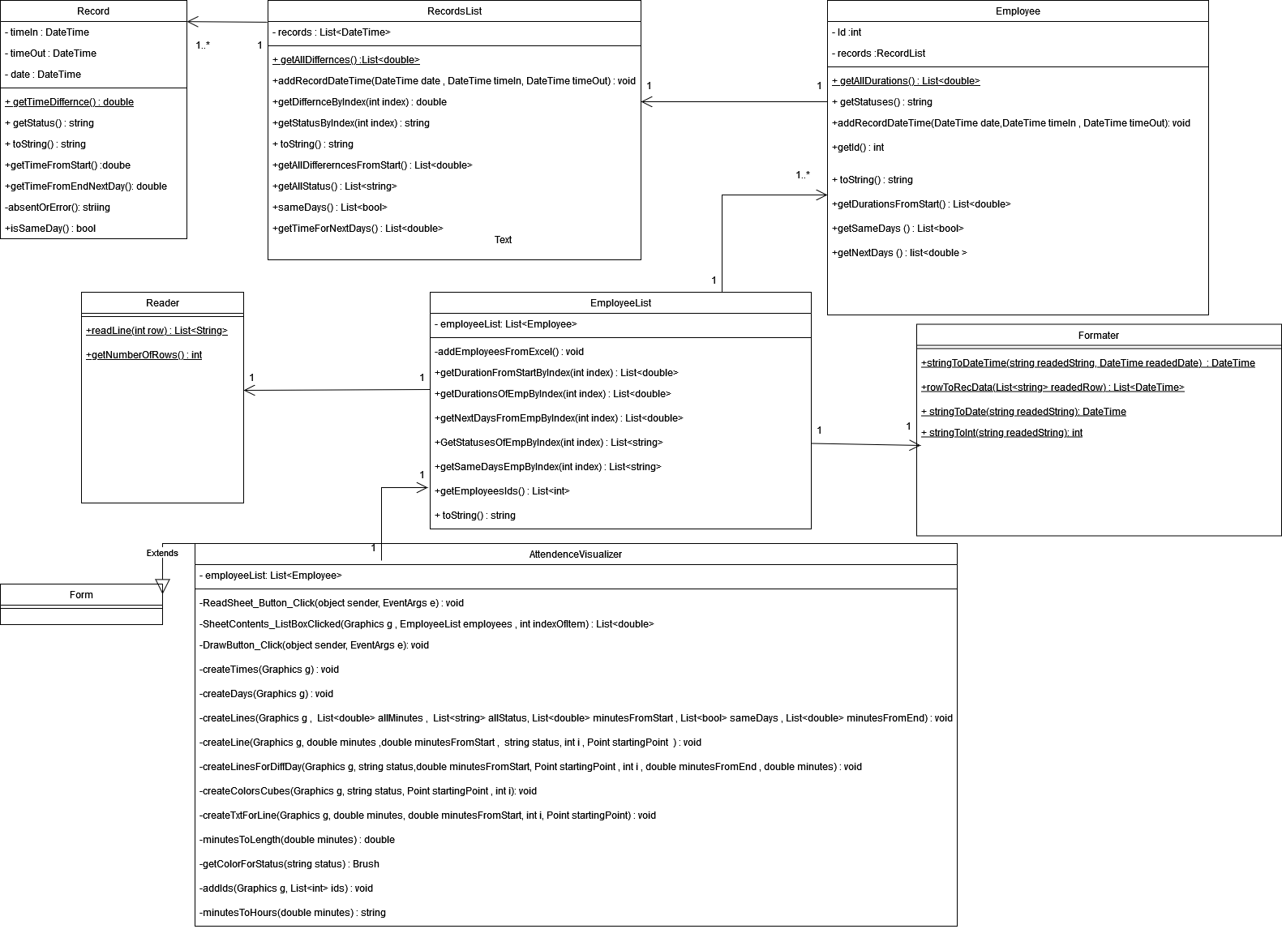
Task 1: Class Diagram

Task 2: Inputs / Outputs

Case 1 and 2 : present and insufficient
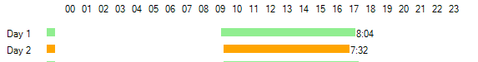
Case 3 : working into the next day
Case 4 / 5 : data error and absent
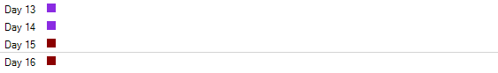
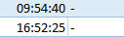
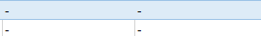

Task 3: Develop the application

Record Class :

using System;
using System.Diagnostics;

namespace AttendanceVisualizer
{
public class Record
{
private DateTime date;
private DateTime timeIn;
private DateTime timeOut;
public Record(DateTime dateReaded,DateTime timeInReaded , DateTime timeOutReaded) {
this.date = dateReaded;
this.timeIn = timeInReaded;
this.timeOut = timeOutReaded;
}
public double getTimeDifference() {
if (absentOrError().Equals("Absent") || absentOrError().Equals("Data error")) {
return 0;
}
TimeSpan diff = (timeOut - timeIn).Duration();
//Trace.WriteLine( "diff in minutes : "+diff + "total mins =" + diff.TotalMinutes);
return diff.TotalMinutes;
}
public double getTimeFromStart() {
TimeSpan diff = (timeIn - date).Duration();
//Trace.WriteLine( "diff in minutes : "+diff + "total mins =" + diff.TotalMinutes);
return diff.TotalMinutes;
}
public double getTimeFromEndNextDay()
{
//Trace.WriteLine(date.Day + ":" + timeOut.Day);
if (date.Day == timeOut.Day){

return 0;
}

DateTime nextDay = DateTime.Now;
nextDay = date;
nextDay = nextDay.AddDays(1);
TimeSpan diff = (timeOut - nextDay).Duration();
//Trace.WriteLine( "diff in minutes : "+diff + "total mins =" + diff.TotalMinutes);
return diff.TotalMinutes;
}
public string getStatus() {
if (timeIn.Equals(new DateTime(1980, 8, 8, 8, 8, 8)) && timeOut.Equals(new DateTime(1980, 8, 8, 8, 8, 8)))
{
return "Absent";
}
else if (timeIn.Day != date.Day || timeIn.Equals(new DateTime(1980, 8, 8, 8, 8, 8)) || timeOut.Equals(new DateTime(1980, 8, 8, 8, 8, 8))) {
return "Data error";
}
double duration = getTimeDifference();

if (duration >= 480)
{
return "present";
}
else
{
return "insuffecient";
}
}
public string toString() {
string formatedRecord = date.ToString() + " " + timeIn.ToString() + " " + timeOut.ToString() + " diff : " + getTimeDifference() +" " + getStatus() + "\n";
return formatedRecord;
}
private string absentOrError() {
if (timeIn.Equals(new DateTime(1980, 8, 8, 8, 8, 8)) && timeOut.Equals(new DateTime(1980, 8, 8, 8, 8, 8)))
{
return "Absent";
}
else if (timeIn.Day != date.Day || timeIn.Equals(new DateTime(1980, 8, 8, 8, 8, 8)) || timeOut.Equals(new DateTime(1980, 8, 8, 8, 8, 8)))
{
return "Data error";
}
else return "no";
}
public bool isSameDay() {
if (timeIn.Day == timeOut.Day) {
return true;
}
return false;
}
}
}

RecordList Class :
using System;
using System.Collections.Generic;

namespace AttendanceVisualizer
{
public class RecordList
{
private List<Record> records = new List<Record>();
public RecordList(List<Record> readedRecords)
{
records = readedRecords;
}
public RecordList(Record readedRecord)
{
records.Add(readedRecord);
}
public RecordList()
{
}
//public void addRecord(Record record)
//{
// records.Add(record);
//}
public void addRecordDateTime(DateTime date, DateTime timeIn, DateTime timeOut) {
records.Add(new Record(date, timeIn, timeOut));
}
public List<double> getAllDifferences() {
List<double> differnces = new List<double>();
for(int i = 0 ; i < records.Count; i++)
{
differnces.Add(records[i].getTimeDifference());
}
return differnces;
}
public List<double> getAllDiffererncesFromStart()
{
List<double> differnces = new List<double>();
for (int i = 0; i < records.Count; i++)
{
differnces.Add(records[i].getTimeFromStart());
}
return differnces;
}
public List<string> getAllStatus() {
List<string> statuses = new List<string>();
for (int i = 0; i < records.Count; i++) {
statuses.Add(records[i].getStatus());
}
return statuses;
}
public double getDifferencebyIndex(int index) {
return records[index].getTimeDifference();
}
public double getDifferenceFromStartbyIndex(int index)
{
return records[index].getTimeFromStart();
}
public string getStatusByIndex(int index)
{
return records[index].getStatus();
}

public string toString() {
string formatedAllRecords = "";
for(int i = 0 ; i < records.Count; i++)
{
formatedAllRecords += records[i].toString();
}
return formatedAllRecords;
}
public List<bool> sameDays() {
List<bool> sameDays = new List<bool>();
for (int i = 0; i < records.Count; i++)
{
sameDays.Add(records[i].isSameDay());
}
return sameDays;
}
public List<double> getTimeForNextDays() {
List<double> nextDays = new List<double>();
for (int i = 0; i < records.Count; i++)
{
nextDays.Add(records[i].getTimeFromEndNextDay());
}
return nextDays;
}
}
}
Employee Class :

using System;
using System.Collections.Generic;

namespace AttendanceVisualizer
{
public class Employee
{
private int id;
private RecordList recordList = new RecordList();
public Employee(int idReaded , RecordList recordListReaded) {

this.id = idReaded;
this.recordList = recordListReaded;
}
public Employee(int idReaded)
{
this.id = idReaded;
}
public Employee()
{
}

public List<double> getDurations() {

return recordList.getAllDifferences();
}
public List<double> getDurationsFromStart()
{

return recordList.getAllDiffererncesFromStart();
}
public int getId()
{
return id;
}
//public void addRecord(Record record) {
// recordList.addRecord(record);
//}
public void addRecordDateTime(DateTime date,DateTime timeIn , DateTime timeOut)
{
recordList.addRecordDateTime(date, timeIn, timeOut);
}
public List<string> getStatuses() {
return recordList.getAllStatus();
}
public string toString() {

return id + "\n" + recordList.toString();
}
public List<bool> getSameDays() {

return recordList.sameDays();
}
public List<double> getNextDays()
{

return recordList.getTimeForNextDays();
}
}
}

EmployeeList class :
using AttendanceVisualizer.proClasses;
using System;
using System.Collections.Generic;
using Excel = Microsoft.Office.Interop.Excel;
namespace AttendanceVisualizer
{
public class EmployeeList
{
private List<Employee> employeesList = new List<Employee>();
public EmployeeList(List<Employee> employeesList) {

this.employeesList = employeesList;
}
public EmployeeList(Employee employee)
{
employeesList.Add(employee);
}
public EmployeeList()
{
AddEmployeesFromExcels();
}

private void AddEmployeesFromExcels()
{
int numberOfRows = Reader.getNumberOfRows();
//Formater formater = new Formater();
for (int i = 2; i < numberOfRows; i++) {
List<string> rowReaded = Reader.readLine(i);

int idFormated = Formater.stringToInt(rowReaded[0]);

List<DateTime> rowFormated = Formater.rowToRecData(rowReaded);
DateTime dateFormated = rowFormated[0];
DateTime timeInFormated = rowFormated[1];
DateTime timeOutFormated = rowFormated[2];
Employee currentEmpReaded;
if (employeesList.Count == 0 || idFormated != employeesList[employeesList.Count - 1].getId())
{
currentEmpReaded = new Employee(idFormated);
employeesList.Add(currentEmpReaded);
}
else {
currentEmpReaded = employeesList[employeesList.Count - 1];
}
currentEmpReaded.addRecordDateTime(dateFormated, timeInFormated, timeOutFormated);

}
}
public List<double> getDurationsOfEmpByIndex(int index)
{
return employeesList[index].getDurations();
}
public List<double> getDurationFromStartByIndex(int index)
{
return employeesList[index].getDurationsFromStart();
}
public List<double> getNextDaysFromEmpByIndex(int index)
{
return employeesList[index].getNextDays();
}

public List<string> GetStatusesOfEmpByIndex(int index) {
return employeesList[index].getStatuses();
}
public List<bool> getSameDaysEmpByIndex(int index)
{
return employeesList[index].getSameDays();
}
public List<int> getEmployeesIds() {
List<int> ids = new List<int>();
for (int i = 0; i < employeesList.Count; i++) {
ids.Add(employeesList[i].getId());
}
return ids;
}
public string toString() {
string formatedString = "";
for(int i = 0; i < employeesList.Count ; i++)
{
formatedString += employeesList[i].toString();

}
return formatedString;
}
}
}
Formater class :

using System;
using System.Collections.Generic;
using System.Diagnostics;
using System.Linq;
using System.Text;
using System.Threading.Tasks;

namespace AttendanceVisualizer.proClasses
{
public class Formater
{
public Formater() { }
public static DateTime stringToDate(string readedString) {
String[] spearator = { "/" };
Int32 count = 3;
string[] time = readedString.Split(spearator, count,
StringSplitOptions.RemoveEmptyEntries);

int year = int.Parse(time[2].ToString());
int month = int.Parse(time[1].ToString());
int day = int.Parse(time[0].ToString());

return new DateTime(year, month, day,0,0,0);
}
public static DateTime stringToDateTime(string readedString, DateTime readedDate)
{
if (readedString.Contains("-"))
{
DateTime errorDate = new DateTime(1980, 8, 8, 8, 8, 8);
return errorDate;
}
else {
// Trace.WriteLine(readedString);
if (readedString.Contains("(+1)"))
{
//Trace.WriteLine(readedDate.ToString());
readedDate = readedDate.AddDays(1);
//Trace.WriteLine(readedDate.ToString());

readedString = readedString.Replace("(+1)", "");
};
String[] spearator = { ":" };
Int32 count = 3;
string[] time = readedString.Split(spearator, count,
StringSplitOptions.RemoveEmptyEntries);

//for (int i = 0; i < time.Length; i++)
//{
// Trace.WriteLine(time[i]);
//}

int hours = int.Parse(time[0].ToString());
int minutes = int.Parse(time[1].ToString());
int seconds = int.Parse(time[2].ToString());
//Trace.WriteLine("hours" + hours + "minutes: " + minutes + "seconds " + seconds);

return new DateTime(readedDate.Year, readedDate.Month, readedDate.Day, hours, minutes, seconds);
}
}
public static List<DateTime> rowToRecData(List<string> readedRow)
{
string dateReaded = readedRow[1];
string timeInReaded = readedRow[2];
string timeOutReaded = readedRow[3];

DateTime dateFormated = stringToDate(dateReaded);
DateTime timeInFormated = stringToDateTime(timeInReaded, dateFormated);
DateTime timeOutFormated = stringToDateTime(timeOutReaded, dateFormated);
List<DateTime> results = new List<DateTime>();

results.Add(dateFormated);
results.Add(timeInFormated);
results.Add(timeOutFormated);
return results;
}
public static int stringToInt(string num) {
return Convert.ToInt32(num);
}
}
}
Reader class :

using System.Collections.Generic;
using Excel = Microsoft.Office.Interop.Excel;
namespace AttendanceVisualizer
{
public class Reader
{
public Reader()
{
}
public static List<string> readLine(int row)
{
Excel.Workbook xWorkBook = Globals.ThisAddIn.Application.ActiveWorkbook;

Excel.Worksheet xWorksheet = xWorkBook.Worksheets.Item[1];
Excel.Range usedRng;
usedRng = xWorksheet.UsedRange;
int numberOfRows = usedRng.Rows.Count;
//int row = 1;
Excel.Range idRead = xWorksheet.Cells[row, 1];
Excel.Range dateRead = xWorksheet.Cells[row, 2];
Excel.Range inRead = xWorksheet.Cells[row, 3];
Excel.Range outRead = xWorksheet.Cells[row, 4];

List<string> rowReaded = new List<string>();
rowReaded.Add(idRead.Text);
rowReaded.Add(dateRead.Text);

rowReaded.Add(inRead.Text);
rowReaded.Add(outRead.Text);

return rowReaded;
}
public static int getNumberOfRows() {
Excel.Workbook xWorkBook = Globals.ThisAddIn.Application.ActiveWorkbook;
Excel.Worksheet xWorksheet = xWorkBook.Worksheets.Item[1];
Excel.Range usedRng;
usedRng = xWorksheet.UsedRange;
int numberOfRows = usedRng.Rows.Count;
return numberOfRows;
}
}
}

AttendenceVisualizer Class :
using System;

using System.Collections.Generic;
using System.ComponentModel;
using System.Data;
using System.Diagnostics;
using System.Drawing;
using System.Linq;
using System.Text;
using System.Threading.Tasks;
using System.Windows.Forms;
using Excel = Microsoft.Office.Interop.Excel;
using static AttendanceVisualizer.Record;
using AttendanceVisualizer.proClasses;
using System.Reflection;
using Microsoft.Office.Interop.Excel;
using Point = System.Drawing.Point;
using ScrollBars = System.Windows.Forms.ScrollBars;
using static System.Windows.Forms.VisualStyles.VisualStyleElement;

namespace AttendanceVisualizer
{
public partial class AttendanceVisulizerForm : Form
{

public AttendanceVisulizerForm()
{

InitializeComponent();

//EmployeeList employees = new EmployeeList();
//Graphics g = TimeLineDrawingPanel.CreateGraphics();

//addIds(g, employees.getEmployeesIds());

//SheetContents_ListBox.Items.Clear();
//SheetContents_ListBox.Click += new EventHandler(delegate (Object o, EventArgs a)
//{
// g.Clear(Color.White);
// int indexOfItem = SheetContents_ListBox.SelectedIndex;
// SheetContents_ListBoxClicked(g, employees, indexOfItem);

//});

}

private void ReadSheet_Button_Click(object sender, EventArgs e )
{
{

EmployeeList employees = new EmployeeList();
Graphics g = TimeLineDrawingPanel.CreateGraphics();

SheetContents_ListBox.Items.Clear();
addIds(g, employees.getEmployeesIds());

SheetContents_ListBox.Click += new EventHandler(delegate (Object o, EventArgs a)
{
g.Clear(Color.White);
int indexOfItem = SheetContents_ListBox.SelectedIndex;
SheetContents_ListBoxClicked(g , employees ,indexOfItem);

});

}

}
private void SheetContents_ListBoxClicked(Graphics g , EmployeeList employees , int indexOfItem) {

createTimes(g);
createDays(g);
drawGrayLines(g);
createLines(g , employees.getDurationsOfEmpByIndex(indexOfItem) ,
employees.GetStatusesOfEmpByIndex(indexOfItem) , employees.getDurationFromStartByIndex(indexOfItem) ,
employees.getSameDaysEmpByIndex(indexOfItem) , employees.getNextDaysFromEmpByIndex(indexOfItem));
}

private void DrawButton_Click(object sender, EventArgs e)
{
//g.DrawString("This is a string", DrawButton.Font, txtBrush, p2, sf); //██████████████████████████████

//g.DrawLine(GreenPen, p1, p2); // ██████████████████████████████
//Graphics g = TimeLineDrawingPanel.CreateGraphics();

//Color timeLineColor = Color.Black;
//Brush timeLineBrush = new SolidBrush(timeLineColor);
//Pen timeLinePen = new Pen(timeLineColor);

//Pen GreenPen = new Pen(Color.Green);
//Brush txtBrush = new SolidBrush(Color.Black);
//StringFormat sf = new StringFormat();
//sf.LineAlignment = StringAlignment.Center;
//sf.Alignment = StringAlignment.Center;

//Point changingPoint = new Point(80, 10);
//Point startingPoint = new Point(80, 10);
//Point endingPoint = new Point(560, 10);

////createTimes(g);
////createDays(g);
////createLines(g);

//DateTime startingDate = new DateTime(2016, 6, 5);
//RectangleF myRectangleF = new RectangleF(30, 30, 40, 10);

}
private void createTimes(Graphics g)
{
Brush txtBrush = new SolidBrush(Color.Black);
StringFormat sf = new StringFormat();
Point changingPoint = new Point(80, 10);
for (int i = 0; i < 24; i++)
{
string drawnString = "0" + i;
if (i >= 10)
{
drawnString = i + "";
}
g.DrawString(drawnString, DrawButton.Font, txtBrush, changingPoint, sf);
changingPoint.Offset(20, 0);
}
}
private void createDays(Graphics g)
{
Point startingPoint = new Point(80, 10);
Brush txtBrush = new SolidBrush(Color.Black);
StringFormat sf = new StringFormat();
for (int i = 1; i <= 90; i++)
{
RectangleF currentRec = new RectangleF(30, 20 + i * 10, 40, 20);
g.DrawString("Day " + i, DrawButton.Font, txtBrush, 10 , 20 + 20*i , sf); //██████████████████████████████
}
}

private void createLines(Graphics g , List<double> allMinutes , List<string> allStatus
, List<double> minutesFromStart , List<bool> sameDays , List<double> minutesFromEnd)
{
//double lengthRec = minutesToLength(minutes);
Point startingPoint = new Point(80, 10);
Brush txtBrush = new SolidBrush(Color.Black);
Brush colordBrush = new SolidBrush(Color.BlueViolet);
StringFormat sf = new StringFormat();
for (int i = 0; i < allMinutes.Count; i++)
{
//Trace.WriteLine("length for end" + minutesFromEnd[i]);
createColorsCubes(g, allStatus[i], startingPoint, i);
if (sameDays[i])
{
createLine(g, allMinutes[i], minutesFromStart[i], allStatus[i], i, startingPoint);
createTxtForLine(g, allMinutes[i], minutesFromStart[i], i, startingPoint);
}
else {
createLinesForDiffDay(g, allStatus[i], minutesFromStart[i], startingPoint, i , minutesFromEnd[i], allMinutes[i]);
}

}
}
private void createLine(Graphics g, double minutes ,double minutesFromStart , string status, int i , Point startingPoint ) {
Brush txtBrush = new SolidBrush(Color.Black);
Brush colordBrush = getColorForStatus(status);
float length = (float)minutesToLength(minutes);
float lengthFromStart = (float)minutesToLength(minutesFromStart);

//g.FillRectangle(colordBrush, (startingPoint.X - 20), 20 + (i+1) * 20, 10, 10);

if(length != 0 && !status.Equals("Absent") && !status.Equals("Data error"))
g.FillRectangle(colordBrush, lengthFromStart + startingPoint.X, +20 + (i+1) * 20, length, 10);
}
private void createLinesForDiffDay(Graphics g, string status,double minutesFromStart, Point startingPoint , int i , double minutesFromEnd , double minutes) {
Brush colordBrush = getColorForStatus(status);
float lengthFromStart = (float)minutesToLength(minutesFromStart);
float lengthForEnd = (float)minutesToLength(minutesFromEnd);
StringFormat sf = new StringFormat();
Brush txtBrush = new SolidBrush(Color.Black);
//Trace.WriteLine("length for end" + lengthForEnd);
if (!status.Equals("Absent") && !status.Equals("Data error")) {
g.FillRectangle(colordBrush, lengthFromStart + startingPoint.X, +20 + (i + 1) * 20, 500 - lengthFromStart, 10);
g.FillRectangle(colordBrush, startingPoint.X, +20 + (i + 2) * 20, lengthForEnd, 10);
g.DrawString(minutesToHours(minutes) + "", DrawButton.Font, txtBrush, lengthForEnd + startingPoint.X, 20 + 20 * (i + 2), sf);
}
}
private void createColorsCubes(Graphics g, string status, Point startingPoint , int i) {
Brush colordBrush = getColorForStatus(status);
g.FillRectangle(colordBrush, (startingPoint.X - 20), 20 + (i + 1) * 20, 10, 10);
}

private void createTxtForLine(Graphics g, double minutes, double minutesFromStart, int i, Point startingPoint)
{
StringFormat sf = new StringFormat();
Brush txtBrush = new SolidBrush(Color.Black);

float length = (float)minutesToLength(minutes);
float lengthFromStart = (float)minutesToLength(minutesFromStart);
float wholeLength = lengthFromStart + length;
//g.FillRectangle(colordBrush, (startingPoint.X - 20), 20 + (i + 1) * 20, 10, 10);
if (length != 0)
g.DrawString(minutesToHours(minutes) + "", DrawButton.Font, txtBrush, wholeLength + startingPoint.X, 20 + 20 * (i+1), sf);
}

private double minutesToLength(double minutes) {
return ((minutes / 60)) * 20;
}
private Brush getColorForStatus(string status) {
Brush colordBrush = new SolidBrush(Color.BlueViolet);
if (status.Equals("Absent"))
{
colordBrush = new SolidBrush(Color.DarkRed);
}
else if (status.Equals("Data error"))
{
colordBrush = new SolidBrush(Color.BlueViolet);

}
else if (status.Equals("present"))
{
colordBrush = new SolidBrush(Color.LightGreen);

}
else if (status.Equals("insuffecient"))
{
colordBrush = new SolidBrush(Color.Orange);
}
else {
colordBrush = new SolidBrush(Color.Black);
}
return colordBrush;
}
private void addIds(Graphics g, List<int> ids)
{
for (int i = 0; i < ids.Count; i++)
{
SheetContents_ListBox.Items.Add(ids[i]);
}
}
private string minutesToHours(double minutes)
{
int hours = (int)minutes / 60;
int minutesRemaining = (int)minutes % 60;
string strMinRem = minutesRemaining.ToString();
if (strMinRem.Length == 1) {
strMinRem = "0" + strMinRem;
}
else if(strMinRem.Length == 0) {
strMinRem = "00";
}

return hours + ":" + strMinRem;
}
private void drawGrayLines(Graphics g) {
Brush colordBrush = new SolidBrush(Color.LightGray);
for (int i = 1; i <= 18; i++) {
g.DrawLine(new Pen(colordBrush), new Point(0, 100 * i + 35), new Point(700, 100 * i + 35));
}
}

//private void Scroller_scroll(object sender, ScrollEventArgs e)
//{
// TimeLineDrawingPanel.VerticalScroll = -Scroller.Value;
//}
}
}

